CREATIVE CORNER

# AN ANONYMOUS PMC STUDENT

The image depicts hope in adverse circumstances. The dull colour scheme of the backdrop and lack of detailing on the ground illustrated the absence of opportunities and ceased possibilities causing a state of despair. Whereas the horizon carried heavenly bodies depicting new worlds of opportunities, stars to represent hope and birds to illustrate possible liberation from adverse ground realities. The subject has opened his arms to the new hope given by an emerging light that has started to appear on the horizon. Overall, the image related that in contrast to the fixation on subtle ground realities, opening up to new possibilities inculcated hope.

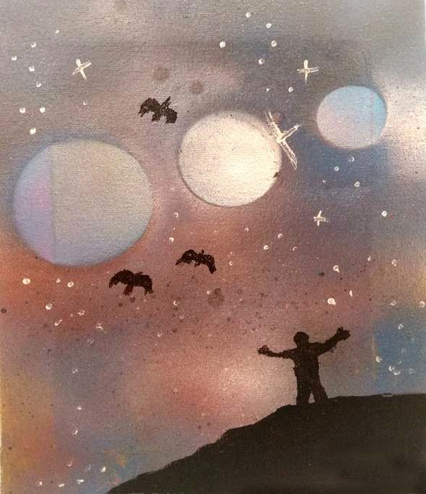

Figure Hope in Adversity

PAGE 24 APRIL-JUNE 2021 VOLUME 18 NUMBER 2